SOCY2200 Statistics Instructor: Natasha Sarkisian
Week 6 Worksheet Answers

Please type up your responses in this document and submit it on Canvas.

- The following graph is from an article discussing how people’s reports of distress change if they are exposed either to information that the United States has a strong (high) democracy or a democracy in trouble (low), with a control group that didn’t discuss democracy at all.
- Based on the error bars in the graph, can we conclude (with 95% confidence) that each group’s distress actually changed (either increased or decreased) between two points (that is, that the change in distress for each group is different from zero, which is represented by the horizontal line in the middle)? [You need to report your conclusions for 6 groups represented by these 6 bars.]
- Based on the error bars in the graph, what can we conclude (with 95% confidence) about the differences by political affiliation for all three conditions? [You need to report your conclusions for 3 comparisons.]

- We are 95% sure that both more liberal and more conservative individuals in low democracy condition experienced a significant increase in distress (because the 95% CI do not cross 0 and are above it); we are also 95% sure that the control group individuals (regardless of political orientation) experienced a significant decrease in distress (because the 95% CI do not cross 0 and are below it); those in high democracy condition did not experience a change in distress regardless of political orientation (because the 95% CI cross 0).
- There is no significant difference between the two control groups and between the two high democracy groups. We need further testing for the high democracy group (because CI overlap but SE do not).
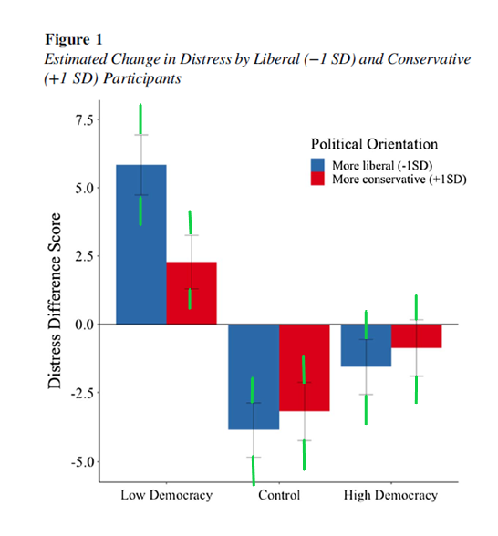
Note: The error bars represent standard errors.

(Source: Benjamin, Rachele; Laurin, Kristin; Chiang, Mindy. 2022. “Who would mourn democracy? Liberals might, but it depends on who’s in charge.” Journal of Personality and Social Psychology,122 (5): 779-805. https://doi.org/10.1037/pspa0000291)

- The following graph is from an article examining the incidence of trypophobia, which is a strong emotion of disgust evoked by clusters of holes or round objects, in urban and rural populations in China. Based on the error bars in the graph, what can we conclude (with 95% confidence) about
(a) the difference between urban and less urban groups in their perceptions of neutral images,
(b) the difference between urban and less urban groups in their perceptions of trypophobic images,
(c) the difference among less urban individuals in perceptions of neutral vs. trypophobic images, and
(d) the difference among urban residents in their perceptions of neutral vs trypophobic images?
[In total, you need to report your conclusions for 4 comparisons.]
(a) There is no significant difference between urban and less urban populations in their perceptions of neutral images
(b) We are 95% confident that there is a difference between urban and less urban populations in their perceptions of trypophobic images (less urban populations rate these images significantly higher than urban populations)
(c) To establish whether there is a difference among less urban individuals in perceptions of neutral vs. trypophobic images, further testing is needed
(d) We are 95% confident that there is a difference among urban residents in their perceptions of neutral vs. trypophobic images (specifically, neutral images are rated significantly higher than trypophobic images)
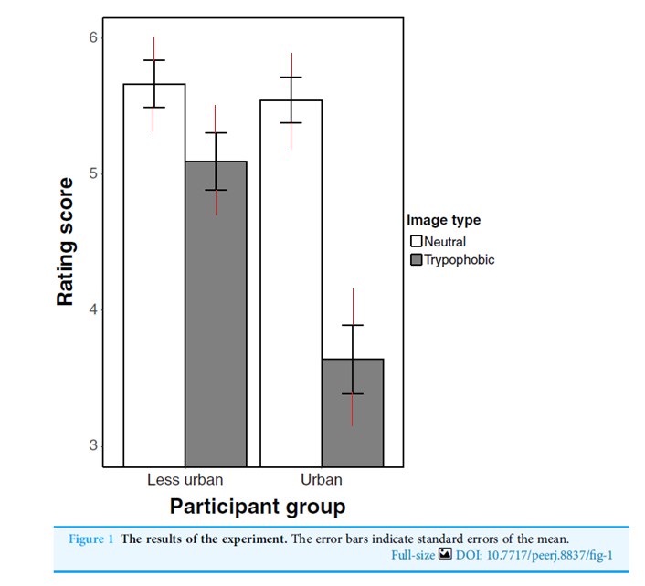
(Source: Zhu, Siqi, Kyoshiro Sasaki, Yue Jiang, Kun Qian, and Yuki Yamada. 2019. “Trypophobia as an urbanized emotion: Comparative research in ethnic minority regions of China.” 10.31234/osf.io/u54vb)

- Based on the error bars in the following graph from an article examining the effects of mindfulness training on food-related sustainable consumption behavior (SCB) among adolescents, what can we conclude (with 95% confidence) about the difference between the intervention and control groups at (a) pre-intervention and (b) post-intervention phase? Also, what can we conclude (with 95% confidence) about the difference between the pre-intervention and post-intervention values for the (c) intervention group and (d) control group? [In total, you need to report your conclusions for 4 comparisons.]
(a) There is no significant difference between the intervention and control groups at pre-intervention.
(b) There is no significant difference between the intervention and control groups at post-intervention phase.
(c) We cannot make any conclusions about the difference between the pre-intervention and post-intervention values for the intervention group because we cannot make conclusions about differences between a pre-test and a post-test for the same people based on the error bars.
(d) We cannot make any conclusions about the difference between the pre-intervention and post-intervention values for the control group because we cannot make conclusions about differences between a pre-test and a post-test for the same people based on the error bars.
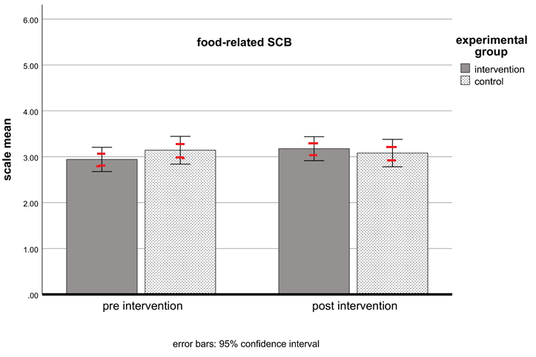
(Source: Böhme, Tina, Laura S. Stanszus, Sonja M. Geiger, Daniel Fischer, and Ulf Schrader. 2018. “Mindfulness Training at School: A Way to Engage Adolescents with Sustainable Consumption?”
Sustainability, 10, 3557; doi:10.3390/su10103557)

4. A public opinion poll asked a random sample of n=900 respondents whether they are in favor of gun restriction laws. It finds 40% being in favor.
- What is the maximum margin of error for this poll (expressed as %)?
Maximum margin of error: 1/sqrt(n)= 1/sqrt(900)=.033
Answer: 3.3% is the maximum margin of error

- What is the actual margin of error for the proportion “in favor” (expressed as %)?

Actual margin of error for 40%: Based on the same calculation as the confidence interval below, 3.2% is the margin of error for this percentage.

- Construct the 95% confidence interval for this proportion (expressed as %); make a probability statement and interpret in words.

Confidence interval: .4 ± 1.96*sqrt((.4*.6)/900)=.4 ± .032

Probability(.368 ≤ p ≤ .432)=.95
Based on our sample of 900 individuals, we are 95% confident that the true proportion in favor of gun restriction laws in the population is between .368 and .432.

