SOCY2200/7702 Statistics Instructor: Natasha Sarkisian
Week 6 Worksheet: Error Bars and Margins of Error Exercises

Please type up your responses in this document and submit it on Canvas.

- The following graph is from an article discussing how people’s reports of distress change if they are exposed either to information that the United States has a strong (high) democracy or a democracy in trouble (low), with a control group that didn’t discuss democracy at all.
- Based on the error bars in the graph, can we conclude (with 95% confidence) that each group’s distress actually changed (either increased or decreased) between two points (that is, that the change in distress for each group is different from zero, which is represented by the horizontal line in the middle)? [You need to report your conclusions for 6 groups represented by these 6 bars.]
- Based on the error bars in the graph, what can we conclude (with 95% confidence) about the differences by political affiliation for all three conditions? [You need to report your conclusions for 3 comparisons.]

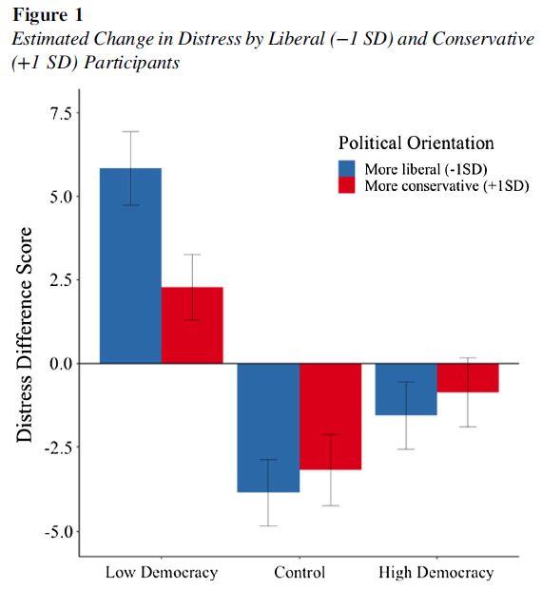
Note: The error bars represent standard errors.

(Source: Benjamin, Rachele; Laurin, Kristin; Chiang, Mindy. 2022. “Who would mourn democracy? Liberals might, but it depends on who’s in charge.” Journal of Personality and Social Psychology,122 (5): 779-805. https://doi.org/10.1037/pspa0000291)

- The following graph is from an article examining the incidence of trypophobia, which is a strong emotion of disgust evoked by clusters of holes or round objects, in urban and rural populations in China. Based on the error bars in the graph, what can we conclude (with 95% confidence) about
(a) the difference between urban and less urban groups in their perceptions of neutral images,
(b) the difference between urban and less urban groups in their perceptions of trypophobic images,
(c) the difference among less urban individuals in perceptions of neutral vs. trypophobic images, and
(d) the difference among urban residents in their perceptions of neutral vs trypophobic images?
[In total, you need to report your conclusions for 4 comparisons.]
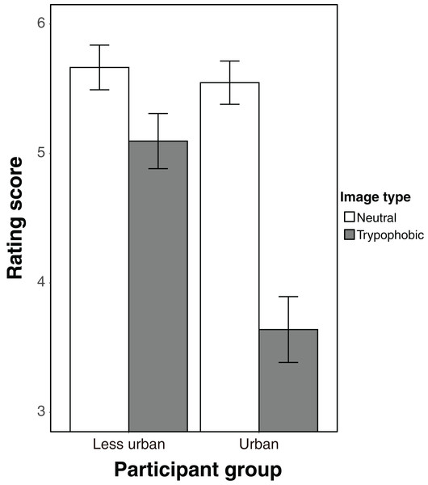

Figure 1: The results of the experiment.
The error bars indicate standard errors of the mean.

(Source: Zhu, Siqi, Kyoshiro Sasaki, Yue Jiang, Kun Qian, and Yuki Yamada. 2019. “Trypophobia as an urbanized emotion: Comparative research in ethnic minority regions of China.” PeerJ 8:e8837 https://doi.org/10.7717/peerj.8837)

- Based on the error bars in the following graph from an article examining the effects of mindfulness training on food-related sustainable consumption behavior (SCB) among adolescents, what can we conclude (with 95% confidence) about the difference between the intervention and control groups at (a) pre-intervention and (b) post-intervention phase? Also, what can we conclude (with 95% confidence) about the difference between the pre-intervention and post-intervention values for the (c) intervention group and (d) control group? [In total, you need to report your conclusions for 4 comparisons.]
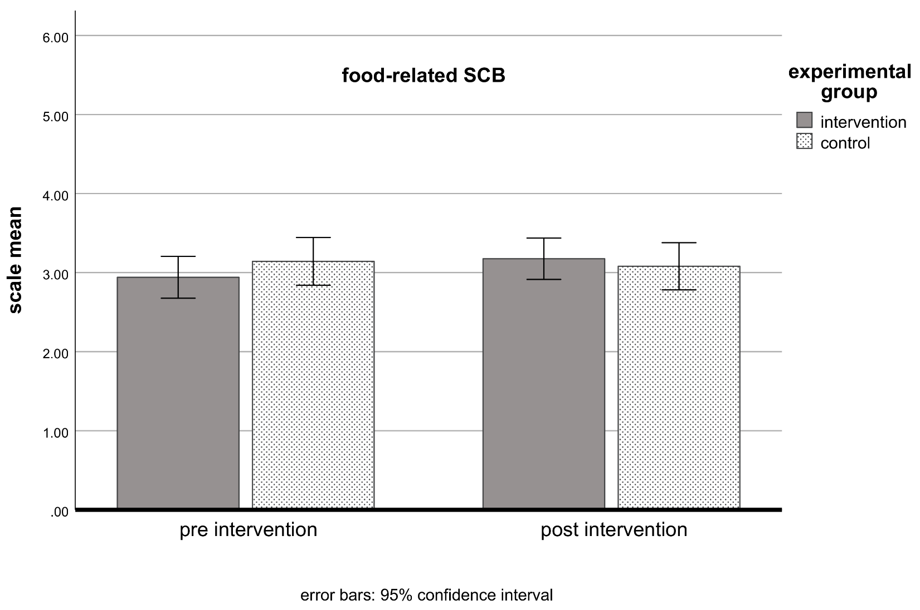
(Source: Böhme, Tina, Laura S. Stanszus, Sonja M. Geiger, Daniel Fischer, and Ulf Schrader. 2018. “Mindfulness Training at School: A Way to Engage Adolescents with Sustainable Consumption?”
Sustainability, 10(10), 3557; https://doi.org/10.3390/su10103557)

- A public opinion poll asked a random sample of n=900 respondents whether they are in favor of gun restriction laws. It finds 40% being in favor.
- What is the maximum margin of error for this poll (expressed as %)?
- What is the actual margin of error for the proportion “in favor” (expressed as %)?
- Construct the 95% confidence interval for this proportion (expressed as %); make a probability statement and interpret in words.

