SOCY2200/7702: Statistics Instructor: Natasha Sarkisian
Worksheet Week 3: Graphs
Part I. Critiquing Graphs
- Are these univariate or bivariate graphs? What types of graphs? What variable or variables do these represent? What is the level of measurement for these variables? What are the observational units here? Which graph better represents information and why?
What Industries Employ Coloradians?
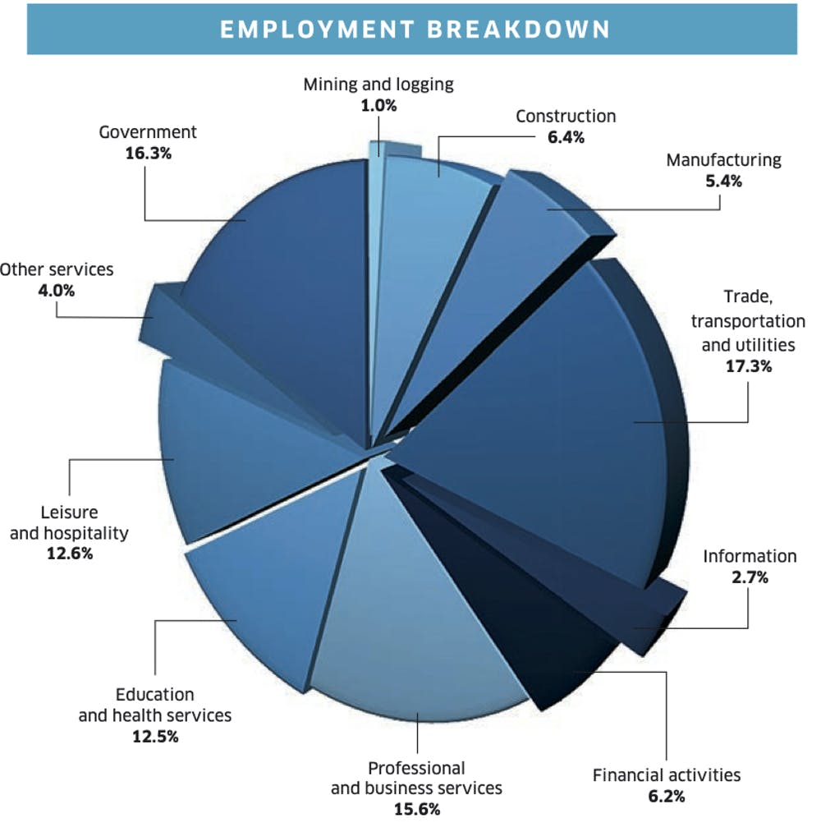
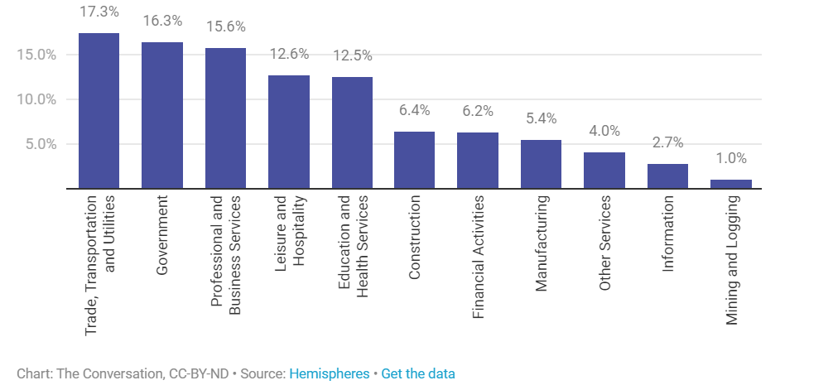
- Is this a univariate or bivariate graph? What type of graph? What variable or variables does it represent? What is the level of measurement for these variables? What are the observational units here? Which of the two versions of the graph better represents the data and why? What criticisms can you offer for these graphs?
Religions of the World
Version 1 Version 2
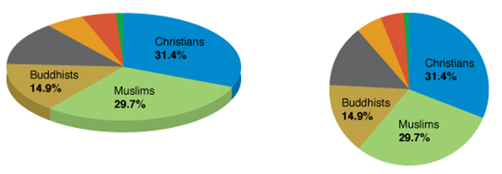
- Is this a univariate or bivariate graph? What type of graph? What variable or variables does it represent? What is the level of measurement for these variables? What criticisms can you offer for this graph?

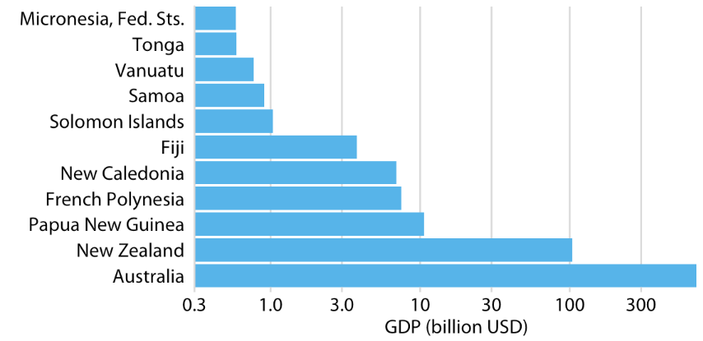

- Is this a univariate or bivariate graph? What type of graph? What variable or variables does it represent? What is the level of measurement for these variables? What criticisms can you offer for this graph?

Percentage of High School Students Who Engage in Some Dangerous Behaviors
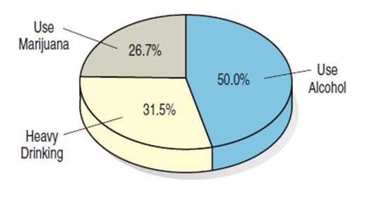
- Is this a univariate or bivariate graph? What type of graph? What variable or variables does it represent? What is the level of measurement for these variables? What are the observational units here? What criticisms can you offer for this graph?
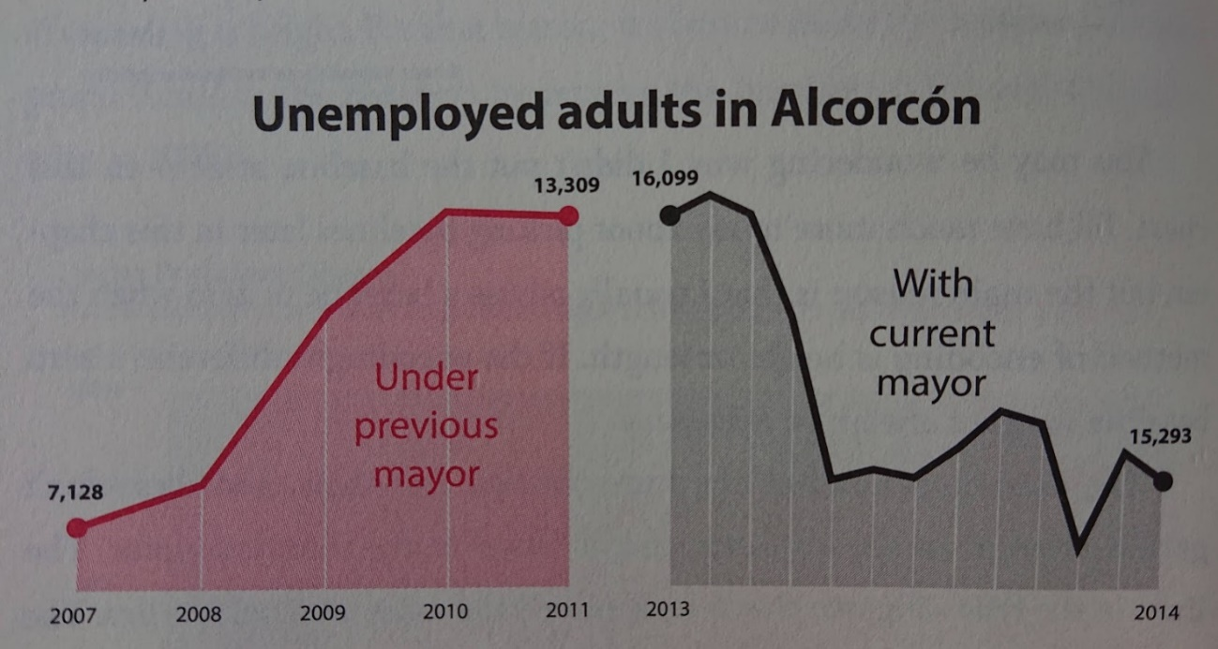
- Find a bar graph, a pie chart or a line graph in a recent news media article. Describe what the chart is showing. Is it clear or confusing? Do you fully understand this chart? Why or why not? What criticisms of the chart, if any, do you have?

Part II. Graphs in Stata.
Open a log file called exercise2.log. Then, using the General Social Survey 2012 data (gss2012.dta, available from Canvas), conduct the following analyses and answer the questions below.

1. Obtain codebook information and frequency distributions for four variables: conpress, conlegis, hrs1, and life. Indicate the level of measurement (nominal, ordinal, interval, ratio) for each of the variables:
conpress ____________________________

conlegis ____________________________

hrs1 ____________________________

life ____________________________

2. Indicate the graph types that are appropriate for each of these variables:

 | Conpress | Conlegis | Hrs1 | Life
Bar graph
Pie chart
Histogram
Boxplot
Stem-and-leaf plot
Frequency polygon
Ogive

3. Construct bar graphs for the variables conpress and conlegis; include percentage labels. Export the graphs into png format. Insert these two graphs into this Word file (make sure to include a header indicating which graph is which!). Based on these two graphs, how would you describe the relative level of confidence in press and in the U.S. Congress?

4. Construct a histogram (with a normal curve) and a boxplot for the variable hrs1. Export these graphs and add them to this word file (once again, make sure to add a header for each). What does each of these graphs tell us about the distribution of values for this variable?

5. Obtain skewness and kurtosis statistics for the variable hrs1.
Skewness statistic value: _______________

Kurtosis statistic value: _______________

What do these statistics tell us about the distribution of hrs1?

6. Construct a pie chart for the variable life; include percentage labels. Export this graph and add it to the word file as well (once again, with a header). Based on this graph, what do the majority of people in this sample think about their life?

Part III. Descriptive Statistics in the News.
Read this article: https://www.theguardian.com/us-news/2025/aug/21/ceo-worker-salaries and the summary of the report that it is based on: https://ips-dc.org/report-executive-excess-2025/.

Download this dataset that the report is based on, called CEO_pay.dta: https://www.sarkisian.net/CEO_pay.dta. Upload it to Stata folder on AppStream using the same process we used for gss2012.dta. Open this data file and calculate descriptive statistics for three variables: CEO pay, median worker pay, and ratio of the two. Also, obtain measures of skewness and kurtosis for each of these variables and construct both histograms and boxplots for each of them (export these graphs and add them to this word file with appropriate headers). Fill out this table:
 | Mean | Median | Central tendency from the report | Skewness | Kurtosis
CEO pay
Median worker pay
Ratio of CEO pay to worker pay

- Which measures of central tendency are presented in the report -- means or medians? Circle the answer.

Means Medians

- Examine all the graphs and statistics you obtained. Do you think means or medians better represent central tendency for each of these variables, and if so, and why? Please circle the answer and explain:

For CEO pay: Mean Median Why? ___________________________________________________

For median worker pay: Mean Median Why? ____________________________________________

For the ratio of the two: Mean Median Why? _____________________________________________

Graphs You Generated in Stata
(insert below with headers):

