SOCY2200 Statistics Instructor: Natasha Sarkisian
Practice Midterm

Note: This practice exam is TWICE AS LONG as the actual exam will be. Once completed, enter your results at https://forms.gle/xbWc8s9vJuwdfbKUA to check yourself, get the link to the full answer key, as well as get participation credit for this exercise [to get points, you have to do it BEFORE the review session, and also submit your log file with inserted graphs to Canvas.]

Problem 1. Distributions
10 people reported the following number of meals/snacks they had the previous day: 5, 5, 3, 7, 2, 4, 5, 4, 5, 5. Construct a frequency distribution (display both counts and percentages) and a cumulative frequency distribution. What percentage of people in this sample eat five meals/snacks a day or fewer?

Problem 2. Descriptive Statistics
Calculate all the measures of central tendency and variability that you know (eight in total) in order to describe the number of meals per day data (variable X) reported in problem 1.

Problem 3. Normal Curve
Assume that a variable IQ is normally distributed with a mean of 100 and a standard deviation of 30. What percentage of people will have scores above 130? What IQ score will have only 10% of the scores below it?

Problem 4. Confidence Intervals
You are interested in estimating the mean number of credits taken by BC students this semester. A random sample of n=25 students report the number of credits, with a mean of 14.4 and a sample standard deviation of s=5. Set the 90% confidence interval for the mean (make a formal probability statement). State in words what this interval means.

Problem 5. Stata: Frequency Distribution. Using Stata and the gss2012.dta dataset, construct the frequency distribution for the variable chldidel. Answer the following questions:
a. The largest percentage of people think that the ideal number of children is ________.
b. _______ % think that 7 or more children is ideal.
c. Based on this frequency distribution, what is the level of measurement of this variable?

Problem 6. Stata: Descriptive Statistics. Using Stata and the gss2012.dta dataset, calculate measures of central tendency and variability to describe the variable maeduc. Answer the following questions.

a. On average, the mean education of respondents’ mothers is ________. The median education of mothers is ________.
b. The typical distance of individual respondents’ mothers’ number of years of education from the average value of this variable is _______.
c. The mode for the respondents’ mothers’ education is ________.

Problem 7. Stata: Graphs. Using Stata and the gss2012.dta dataset, construct bar charts for the variables happy and health. Make sure to include percentage labels in the charts and export your graphs to be included with your log. Is a larger percentage of people report being “very happy” or report being in excellent health?

Problem 8. Stata: Confidence Intervals. Using Stata and the gss2012.dta dataset, construct 90% confidence interval for the mean of maeduc variable.
- Make a formal probability statement for this interval:

- State this confidence interval in words:

- Fill the blanks: The probability of error (alpha) in this case is ________, which means

there is a ________ % chance that the actual mean for the U.S. population is

________________________________________________________________.

Problem 9. Stata: Skewness/kurtosis. Using Stata and the gss2012.dta dataset, construct a histogram with a normal curve for the variable maeduc as well as obtain skewness and kurtosis statistics. Is the distribution of maeduc symmetric (normal) or skewed, and if skewed, what is the direction of that skew? What can we conclude with regard to the kurtosis of that distribution?

Please do not forget to open a log file and export your graphs – you will have to submit them on Canvas.

Multiple Choice Questions:
1. A variable measuring household wealth has a range from -20K to 20 million, with only a few people in the sample reporting wealth above 1 million. The best measure of central tendency for this variable will be:
  - mode
  - median
  - mean
  - range
  - interquartile range
_
2. A public opinion poll asked a random sample of n=400 respondents whether they are in favor of capital punishment. What is the maximum margin of error for this poll?
a. ±1.4%
b. ±2%
c. ±3%
d. ±5%
e. ±7.5%

3. For a variable measuring religious affiliation (with response categories Muslim, Catholic, Protestant, Jewish, etc.), the best measure of central tendency is:
- mode
- median
- mean
- variance
- range

4. If a value has a z-score of -2:
- it is two variances above the mean of normal distribution
- it is two variances below the mean of normal distribution
- it is two standard deviations above the mean of normal distribution
- it is two standard deviations below the mean of normal distribution
- it is non-existent because z-scores cannot be negative

5. The distribution on this histogram looks:
  - positively kurtotic
  - negatively kurtotic
  - positively skewed
  - negatively skewed
  - normal
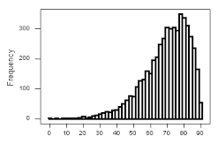
6. Sampling distribution of the mean:
- is skewed if the variable has a skewed distribution in the population
- has a larger standard deviation that population standard deviation
- can be used as a sampling frame in order to draw a random sample
- has zero degrees of freedom
- has a mean equal to the population mean

7. If the confidence level for a confidence interval is 95%, we know that:
- out of 100 samples, 5 will have a sample mean outside the confidence interval
- out of 100 samples, 5 will have a wider confidence interval
- out of 100 samples, 5 will have a confidence interval not including the true mean
- out of 100 observations, 5 will be different from the population mean
- out of 100 observations, 5 will not have a confidence interval

8. The width of a confidence interval:
- increases as sample size increases
- decreases as sample size increases
- decreases as the confidence level increases
- increases as the mean increases
- decreases as the mean increases

9. If we increase the confidence level from 95% to 99% and the sample size stays the same:
- the probability of error (alpha) increases
- the width of the confidence interval decreases
- the width of the confidence interval increases
- the width of the confidence interval remains the same
- the margin of error decreases

10. The error bars on a bar chart:
- are always wider when they reflect the confidence interval rather than the standard error
- are always wider when they reflect the standard error rather than the confidence interval
- always overlap across groups
- never overlap across groups
- are never used with means or proportions

11. The mean of normal distribution is also:
- its variance
- its standard deviation
- its median and mode
- its z-score
- its sample size
12. Based on the error bars in the following graph, what can we conclude about differences in the level of essentialism in perceptions of these four groups?
a. We can be 95% confident that perceptions of biological fathers are more essentialist than perceptions of adoptive fathers.
b. We can be 95% confident that perceptions of biological mothers are more essentialist than perceptions of adoptive mothers.
c. We cannot be 95% confident that the perceptions of adoptive mothers and biological mothers are different.
d. We cannot be 95% confident that the perceptions of biological mothers and biological fathers are different.
e. We can be 95% confident that perceptions of adoptive mothers are more essentialist than perceptions of adoptive fathers.

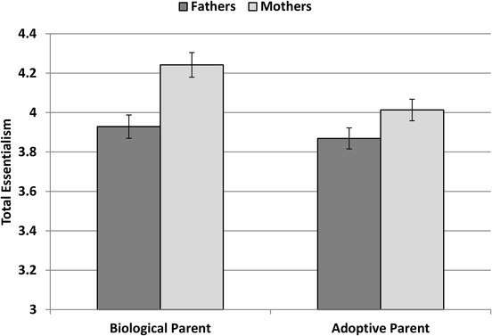
Figure 1. Mean ratings on aggregate essentialism for biological versus adoptive fathers and mothers. Error bars reflect the standard error of the mean.

13. Based on the following frequency distribution, what is the level of measurement for this variable?
a. ordinal
b. binary
c. interval
d. dichotomous
e. nominal

TOTAL FAMILY |
INCOME | Freq. Percent Cum.
---------------+-----------------------------------
LT $1000 | 25 1.42 1.42
$1000 TO 2999 | 26 1.48 2.90
$3000 TO 3999 | 18 1.02 3.92
$4000 TO 4999 | 10 0.57 4.49
$5000 TO 5999 | 8 0.46 4.95
$6000 TO 6999 | 24 1.37 6.31
$7000 TO 7999 | 24 1.37 7.68
$8000 TO 9999 | 38 2.16 9.84
$10000 - 14999 | 140 7.96 17.80
$15000 - 19999 | 106 6.03 23.83
$20000 - 24999 | 125 7.11 30.94
$25000 OR MORE | 1,214 69.06 100.00
---------------+-----------------------------------
Total | 1,758 100.00

14. What is the most important problem that you can identify with the following graph?
  - Labels are confusing
  - The Y (vertical) axis does not start where it should
  - Categories are overlapping
  - A pie chart would represent these data better
  - Bars have the same color and shading
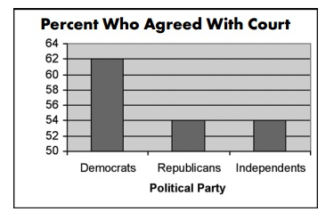
15. The standard error of the mean is:
        - the standard deviation in the sample
        - the standard deviation in the population
        - the square root of the standard deviation in the population
        - the distance between the sample mean and a given value of X
        - the standard deviation of the sampling distribution of the mean

16. Based on the following output, we can conclude that this variable is:
a. positively skewed
b. negatively skewed
c. approximately normal
d. leptokurtic
e. platykurtic

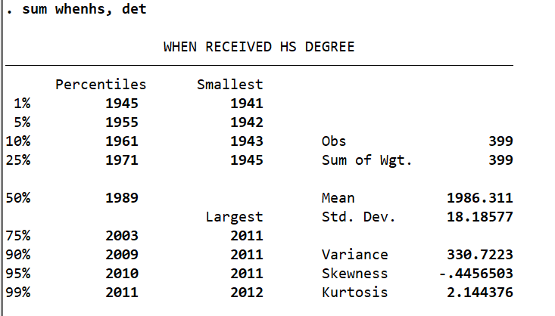

17. The following graph is a:
  - univariate histogram
  - bivariate histogram
  - univariate bar graph
  - bivariate bar graph
  - univariate line chart
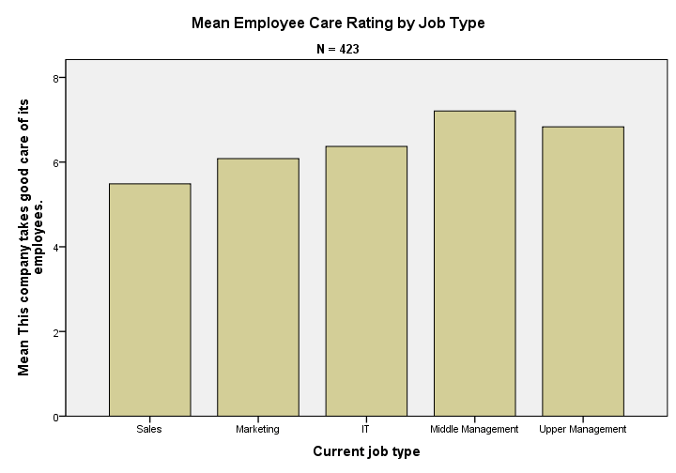
18. A study examines differences between women and men in their levels of daily exercise among older adults in the United States. What is the unit of observation in this study?
  - men
  - women
  - the United States
  - older adults
  - levels of daily exercise

19. On the following boxplot:
  - outliers are the values higher than 61
  - outliers are the values smaller than 33
  - 50% of all observations are between 33 and 61
  - 50% of all observations are above 61
  - the middle line (at 47) indicates the mean of this variable
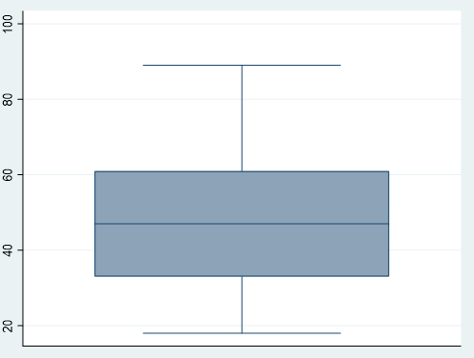

20. What is the most important problem that you can identify with the following graph?
- It violates that proportional ink principle
- It does not provide axis labels
- It is inconsistently labeling slices
- The categories are not mutually exclusive
- The legend is not clear

