SOCY2200 Statistics Instructor: Natasha Sarkisian
Handout: Using the Normal Curve.

Formulas to use:
z=(X - $\overline{X}$)/s (to calculate a z-score: observation – mean, then divide by SD)
X=$\overline{X}$ + zs (to calculate the original score from a z-score: multiple z score by SD, then add the mean)

1. The first type of problem asks you to find the percentage of cases above or below a given point in a normal curve or the percentage between two points. The mean and standard deviation are given. You are to assume you know that the curve is normal. The general algorithm for solving this type of problems is:

X →[use formula z=(X-$\overline{X}$)/s]→ z →[use table B1 to find proportion for your z]→ percentage (between your z and z=0)

Example A.
Given a normal curve with mean of 50 and a standard deviation of 10, find the percentage of scores that will fall above a score of X=60.

Step 1: Convert X to z: z=(X-$\overline{X}$)/s = (60-50)/10 = +1
Step 2: Enter Table B1 (in Salkind) with z= +1.00 and read 34.13.
Step 3. Since the percentage between z=0 and z= +1.00 is 34.13, the proportion above Z= +1.00 must be 50.00 – 34.13 = 15.87
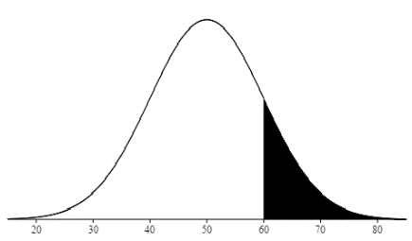

IMPORTANT: When you enter the table with some value of z, you always read the percentage between z=0 and your value of z. However, you will often need to find the percentage above your value of z, below your value of z, or between two values of z. Use the fact that the percentage of scores that fall under the whole curve is 100% and the percentage of scores that fall under any half of the curve is 50%. And always draw a picture to not get confused!

Example B.
Given a normal curve with a mean of 20 and a standard deviation of 5, find the percentage of scores below X=12.

Step 1: Convert X to z: z=(X-$\overline{X}$)/s = (12-20)/5 = -1.6.
Step 2: Enter Table B1 with z = -1.6. Since only the positive half of the curve is shown, you must enter with +1.6. The resulting percentage (percentage between z=0 and z= +1.6) is 44.52.
Step 3. The amount above Z=+1.6 must be 50.00 – 44.52 = 05.48. Because the normal curve is symmetric, the same percentage of cases will be above +1.6 as will be below -1.6, so the answer is 05.48 of the scores will be below X=12.
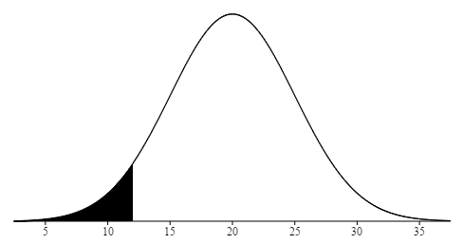

Example C.
Given a normal curve with a mean of 75 and a standard deviation of 8, find the percentage of scores between 67 and 83.

Step 1: Convert both X=67 and X=83 to z scores. z=(X-$\overline{X}$)/s = (67-75)/8 = -1. And, z=(83-75)/8 = +1.
Step 2: For z = +1.00, the percentage between z=0 and z=1 is read to be 34.13 in the Table B1. Since the curve is symmetric, the same percentage will be found between z=0 and z= -1.00.
Step 3. So the answer is 34.13 + 34.13 = 68.26 of the scores will be between 67 and 83.
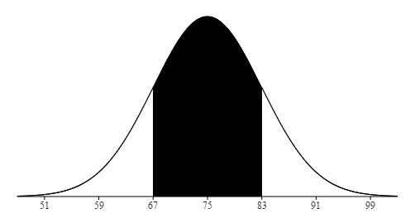

Example D.
Given a normal curve with a mean of 60 and a standard deviation of 4, find the percentage of scores above 52.

Step 1: Convert X=52 to a z-score: z=(X-$\overline{X}$)/s = (52-60)/4 = -2. Note that this is below the mean, so we need both the area from z=-2 to the mean and the entire 50% above the mean.
Step 2: The percentage between z=0 and z=2 is read to be 47.72 in the Table B1.
Step 3. Since the curve is symmetric, the same percentage will be found between z=0 and z= -2. So the answer is 50.00 + 47.72 = 97.72% of the scores will be above 52.
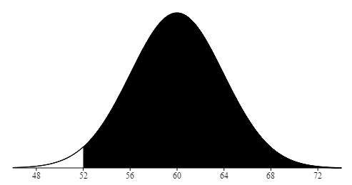

2. The second type of problem tells you the mean and standard deviation of a normal curve, gives you a percentage and asks to find the X score (or scores) that cuts off that percentage. The general algorithm for solving this type of problems is:

Percentage → [use table to find z for percentage] → z → [use formula X=$\overline{X}$ + zs] → X

Example E.
Given a normal curve with a mean of 80 and a standard deviation of 5, find the X value such that only 5% of the cases are above it.

Step 1: Enter the Table B1 with the percentage (2nd, 4th and so on columns) and read z (approximate the percentage value as needed). The score we are seeking should cut off the top 5%, but we can only enter the table with the percentage of scores between the mean and the X value we need, so we enter with 50.00 – 05.00 = 45.00. The closest entry is z = 1.65 which has 45.05 falling between it and z=0. Or, z=1.64 which is about 44.95 falling between it and z=0. Since they are equally close, we can use either one, say, 1.65.
Step 2: You know that z = 1.65, but you must convert it to X. If z=(X-$\overline{X}$)/s then z*s= (X-$\overline{X}$), which implies that X = $\overline{X}$ + z*s. For our data, X=80 + (1.65*5) = 88.25. About 5% of the scores will exceed X=88.25.
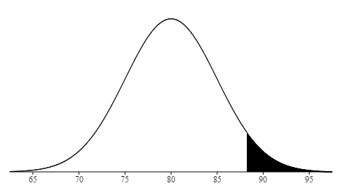

Example F.
Given a normal curve with a mean of 50 and a standard deviation of 10, find the 2 values of X that include the middle 80% of the distribution.

Step 1: Since the Table B1 deals only with the right side of the curve, we should “convert” our problem accordingly. Let’s find the right side percentage, that is, right half of 80%. Half of 80% is 40%. The score we are seeking should cut off 40% between z=0 and z for that score. We enter the table with percentage 40.00. The closest to 40.00 is .3997 for z=1.28. At this point, only 10% will fall above the point. Because the curve is symmetric, only 10% will fall below the point z = -1.28. That means that the two points that include the middle 80% will be z = -1.28 and +1.28.
Step 2: The z values (-1.28 and +1.28) must be converted to X values. From example A we know that X = $\overline{X}$ + z*s. So, X1=50+(-1.28*10)=37.2 and X2=50+(1.28*10)=62.8. About 80% of the curve will fall between 37.2 and 62.8.

