Sociology 2200: Statistics Instructor: Natasha Sarkisian
Interpreting Error Bars on Graphs

What are error bars?
Error bars is a way to indicate the degree of uncertainty (and provide interval estimates rather than point estimates) on graphs. They are usually used on either bar or line graphs, but can also appear on dot plots and scatterplots (dot plots are similar to line graphs, but with dots rather than lines; and we’ll discuss scatterplots later). Here’s how they look like:
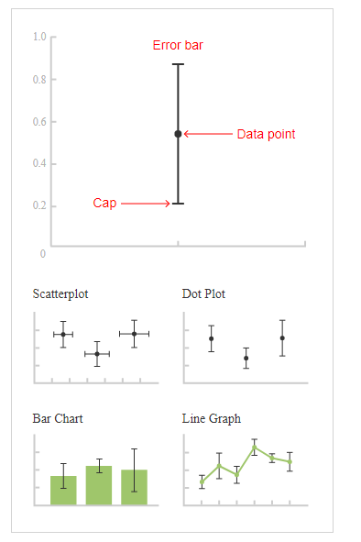
The same things that make confidence intervals wider, also make error bars longer. That is:
- Smaller sample size longer error bars
- Less homogenous population longer error bars
- Higher confidence level longer error bars
So when on the SAME bivariate graph, one error bar is longer than the others, it is very likely that this group has a much smaller sample size. For example, in the following graph, there were likely very few children in the “always” group:
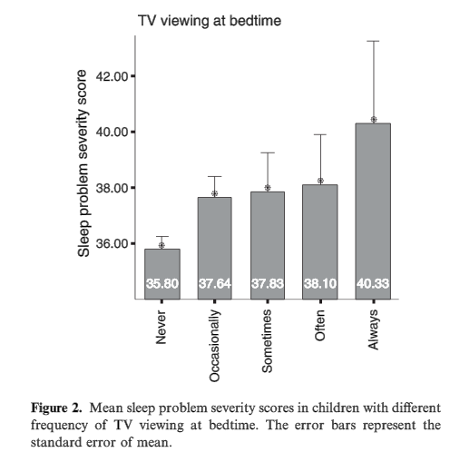
(Source: E. Juulia Paavonen, Marjo Pennonen, Mira Roine, Satu Valkonen, & Anja Riitta Lahikainenj. "TV Exposure Associated With Sleep Disturbances in 5- To 6-Year Old Children." 2006. Sleep Research 15, 154–161.)

Note that on this graph, the error bars are only drawn up – it is still implied that they go both directions though so what’s on the plot is only one half of the actual error bar. This kind of plot with a one-directional error bar is also called “dynamite plot,” and it’s not recommended to use it.

Types of error bars and interpretation
When I said that confidence level determines the length of the error bar, that is actually a bit simplified. Beyond just the confidence level, the length of the error bar will be different depending on its type. So to interpret them, we first need to establish the type of error bar. Three key types:
- Confidence interval (typically 95% CI, but can be 90% or 99%)
- Standard error, also labeled SE, standard error of the mean, or SEM
- Standard deviation

I recommend confidence interval error bars, they are the most informative; but standard error ones are also very often used.

For the length of error bars:
- standard deviation>99% confidence interval > 95% CI > 90% CI > standard error
For example, here’s a comparison of three types of error bars for the same exact data:
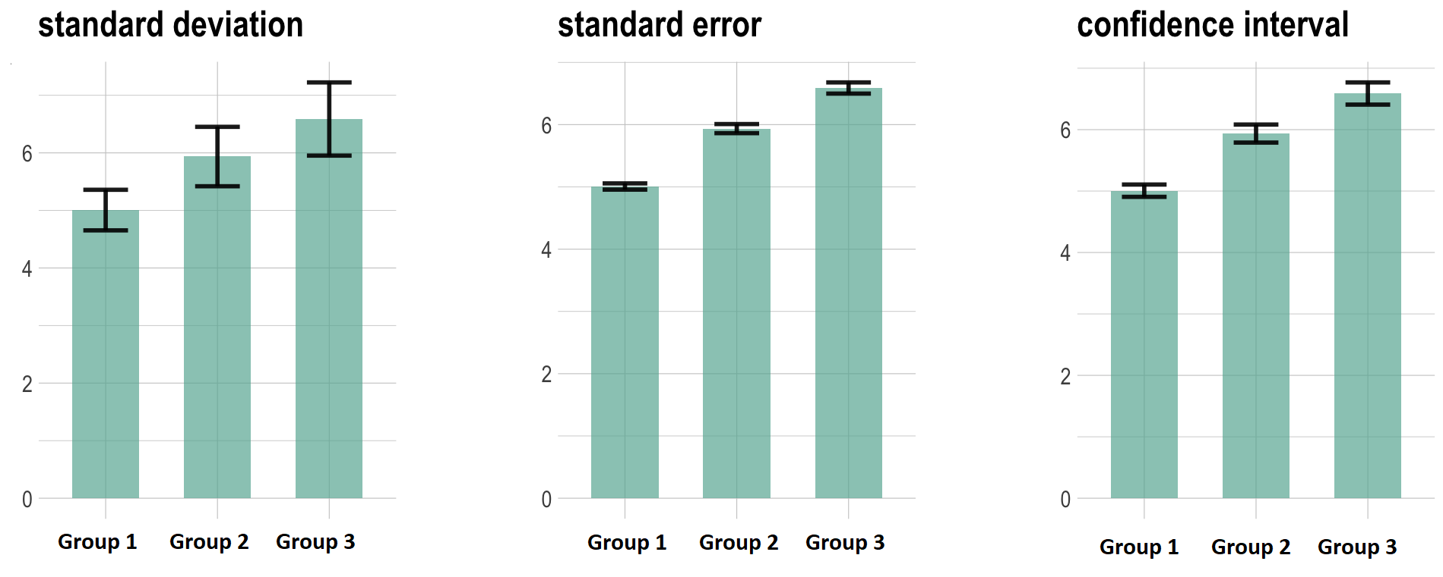
When examining graphs with error bars, check the labels, legends and notes for the type of error bars used. For example, the graph on the previous page says “the error bars represent the standard error of mean.” You cannot distinguish them visiually!

Comparing Groups Based on Error Bars

If we use error bars to compare across groups (on a bivariate bar graph or line chart), we do it based on the overlap.
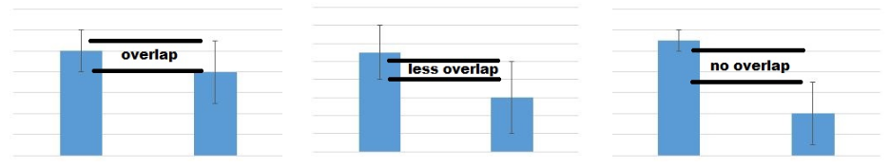
Algorithm for making group comparisons using error bars
Step 1. Need both CI and SE = determine the type and transform:
SE double it CI
CI cut it in half SE

Step 2. Compare and conclude:
1. Both SEs & CIs overlap No significant difference
2. Both SEs & CIs do not overlap 95% confident that different
3. CIs overlap but SEs do not No conclusion, further testing needed

Caution -- special cases:
Standard deviation error bars No conclusion, further testing needed
Paired data (e.g., pretest & posttest) No conclusion, further testing needed

In Step 2, you should draw SE if your current intervals are CI, and draw CI if they are SE. Note, however, if SE overlap, we would know that CI will overlap as well, and when CIs do not overlap, we would know that SE would not overlap either. So in those situations, you can skip drawing step.

Based on this algorithm, here’s what overlap and its lack means for the two key types of error bars:
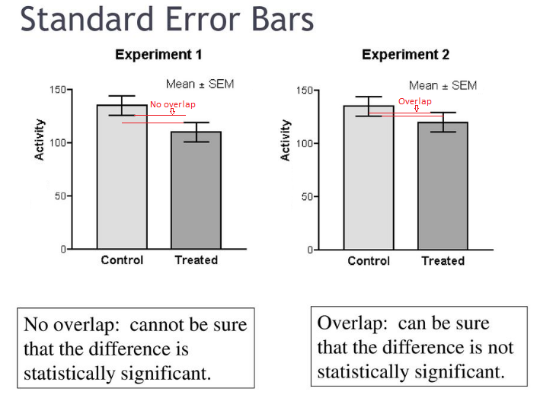
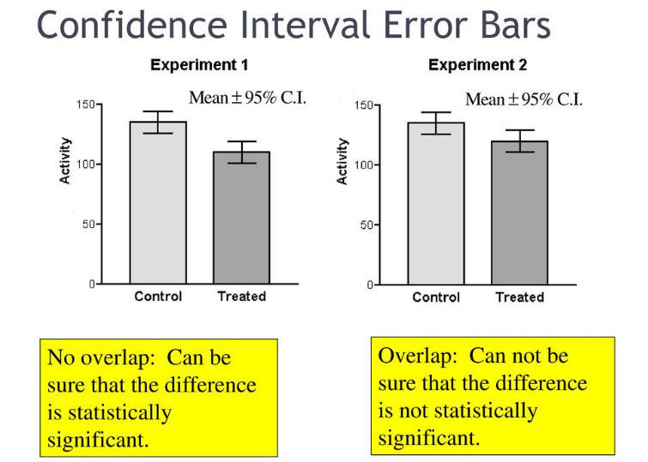

Here’s one more example that presents all three types of error bars for the SAME DATA:
Standard deviation error bars | 95% confidence interval error bars | Standard error of mean error bars:
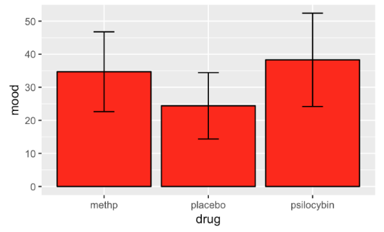 | 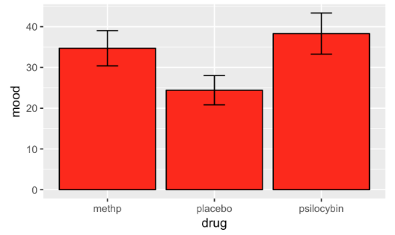 | 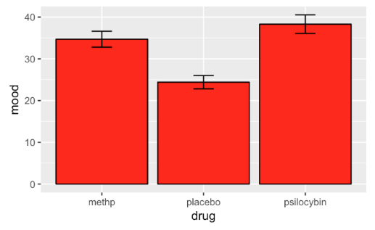
- all three overlap  - in general, not much to conclude based on this graph (standard deviation error bars are not informative for group comparisons) | - placebo does not overlap with either of the other groups we can be 95% sure that placebo group is different from the other two  - methp and psilocybin overlap with each other we cannot be sure whether the difference is statistically significant, more testing is needed (although there is so much overlap that I am pretty sure there is no significant difference here; we can cut the length in half to get SEM, as in the next column, and make a firmer conclusion) | - methp and psilocybin overlap there is definitely no significant difference between these two  - placebo does not overlap with either methp and psilocybin we cannot be sure whether the difference between placebo and each of the other groups is statistically significant; more testing is needed (or we can double the length of the bars to get 95% CI, as in the previous column, and make a firmer conclusion)

Examples of group comparisons using error bars

Example 1: Confidence Interval Error Bars
Source: Alexander L. N. van Nuijs et al. 2009. “Can cocaine use be evaluated through analysis of wastewater? A nation-wide approach conducted in Belgium.” Addiction, 104, 734–741.
Step 1: Type of Error Bar = 95% Confidence Intervals
Step 2: Look if overlap yes
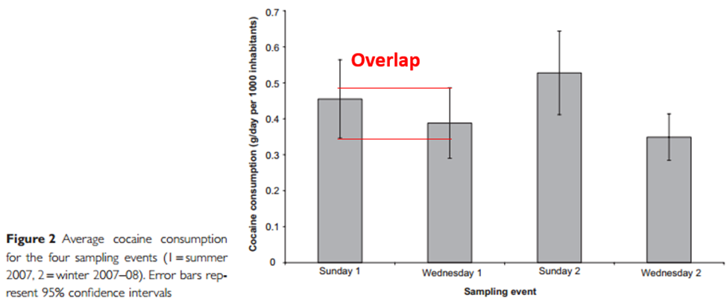
Step 3: Since confidence intervals overlap, divide in half to see if standard errors overlap:
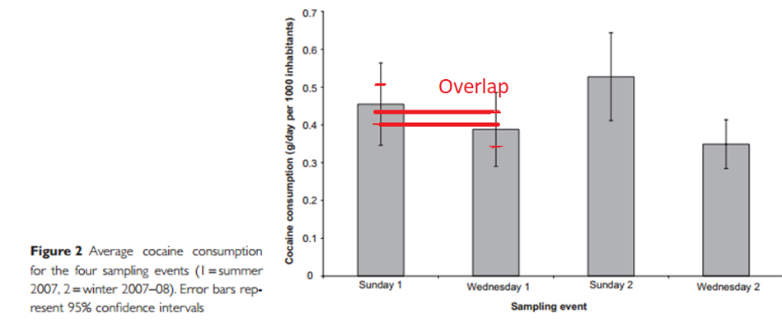
Step 4. Standard errors are also overlapping no significant difference between Sunday 1 and Wednesday 1 means
Example 2: Standard Error Bars
We would like to compare web use for 25-34 and 55+.

Step 1: Type of Error Bar = Standard Error of Mean
Step 2: Look if they overlap No
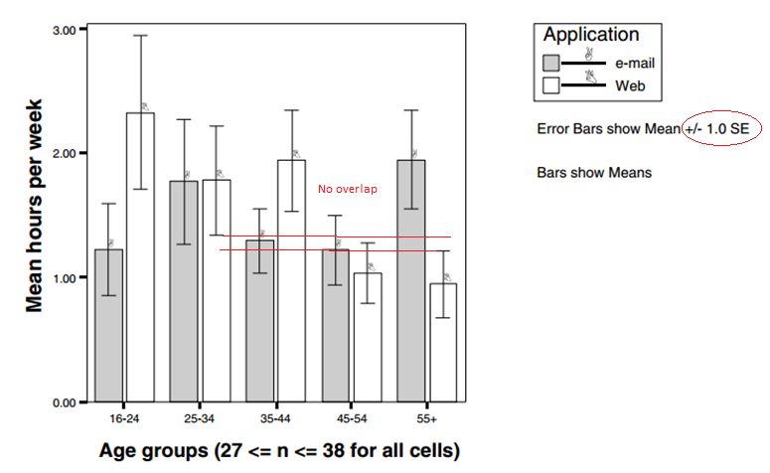
Figure 3. Mean Hours Per Week Spent on Email or Web Browsing by Diary Respondents in Wave 2 in 2000
Source: Ben Anderson & Karina Tracey. 2001. “Digital Living: The Impact (or Otherwise) of the Internet on Everyday Life.” American Behavioral Scientist 45(3):456-475.

Step 3: No overlap need to double the error bars to examine confidence intervals. We double the bar both up and down (vertical red lines are the new error bars; they are equivalent to 95% CI):
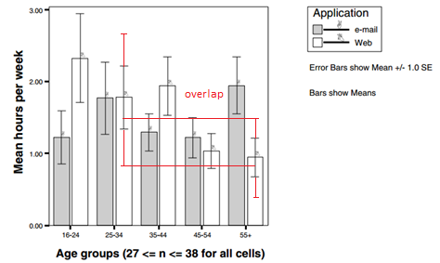
Step 4: Confidence intervals are overlapping we cannot reach a firm conclusion from the graph on whether 25-34 year old individuals and 45-54 years old ones differ significantly in their mean hours of email per week, further statistical testing is needed.

Comparing Error Bars to a Certain Value

There may be another kind of comparison we could be interested in when it comes to error bars – we may want to compare if some mean or percentage is different from some benchmark or threshold. For example, here, we would like to compare which types of job search approaches in MBA job searches resulted in offers with total compensation amounts below average (which is the red horizontal line).
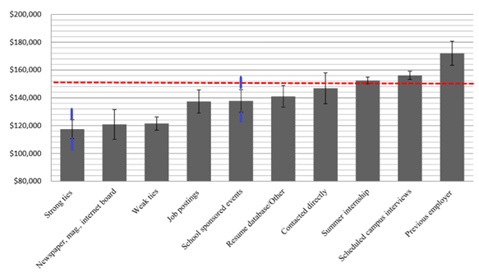
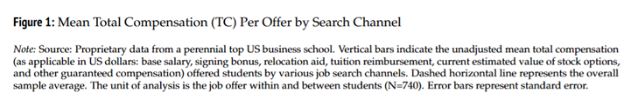
(Source: Jason Greenberg and Roberto M. Fernandez. 2016. “The Strength of Weak Ties in MBA Job Search: A Within–Person Test.” Sociological Science 3: 296-316. DOI 10.15195/v3.a14)

These are standard errors, so to check whether we can be 95% sure that a particular approach has a mean compensation amount below or above the average, we first need to construct confidence intervals by doubling the SE (one more up, one more down). That is what I did (see blue lines for strong ties and school sponsored events). Once we double the standard error bars and create confidence intervals, we see that the one for strong ties does not cross the red line, and the one for school sponsored events does. Therefore, we are 95 certain that strong ties result in offers with compensations significantly below average. However, it appears that school sponsored events result in offers with compensations not different from average (or at least we cannot be 95% sure that they are different from average).

