Name: __________________________________

SOCY2200 Statistics Instructor: Natasha Sarkisian

Multiple Choice Test 2

Please answer the following multiple choice questions, then fill in the corresponding bubbles in the scantron sheet. Make sure to mark your answers both here and on the scantron sheet.

1. If a value has a z-score of 3, this value:
- has a standard error = 3
- is three standard deviations above the mean of a normal distribution
- is three standard deviations below the mean of a normal distribution
- is three variances away from the mean of a normal distribution
- has 3 degrees of freedom (df=n-1)

2.The median of a normal distribution:
- is equal to its mean
- is equal to its standard deviation
- is equal to its variance
- has a z-score of 1
- is more affected by the outliers than the mean

3. Sampling distribution of the mean:
- is positively skewed if the population distribution has a positive skew
- is positively skewed if the population distribution has a negative skew
- has a smaller standard deviation than that in the population
- has a larger standard deviation than that in the population
- is represented by the sampling frame

4. If the confidence level for a confidence interval is 90%, that means, if we keep taking samples repeatedly:
- the sample mean will fall outside the confidence interval in 1 sample out of every 10
- the sample mean will fall inside the confidence interval in 1 sample out of every 10
- it will be impossible to construct a 90% confidence interval in 1 sample out of every 10
- the true population mean will fall inside the confidence interval in 1 sample out of every 10
- the true population mean will fall outside the confidence interval in 1 sample out of every 10

5.The width of a confidence interval:
- increases if the population mean increases
- decreases if the population mean decreases
- decreases as the confidence level increases
- increases as the confidence level increases
- increases if the random error component decreases

6. If, for a given sample size and a given level of population heterogeneity, we decrease the confidence level from 95% to 90%:
- the margin of error corresponding to the interval decreases
- the margin of error corresponding to the interval increases
- the probability of error (alpha) decreases
- the probability of error (alpha) remains the same
- the width of the confidence interval increases
7. The error bars on a line chart:
- are wider if they reflect the confidence interval than the standard error
- are less wide if they reflect the confidence interval than the standard error
- are wider than they would be on a corresponding bar chart
- are less wide than they would be on a corresponding bar chart
- if displayed, indicate that there are significant differences between time points

8. If we repeatedly draw samples from the same population and calculate the mean each time, the resulting distribution will:
- contain the sample mean 95% of the time
- contain the true population mean 95% of the time
- have more spread than the original population
- be normal
- be leptokurtic

9. For a public opinion poll with a sample size of 100 where 50% of those polled support Proposition 1, the margin of error would be:
- 1%
- 2%
- 3%
- 5%
- 10%

10. Based on the error bars in the graph below, what can we conclude about differences in mean coping with workplace stress scores?
- We can be 95% confident that high activity level group is different from the low activity group.
- We can be 95% confident that high activity level group is different from the moderate activity group.
- We can be 95% confident that high activity level group is different from the sedentary group.
- Further testing is needed to establish if high activity level group is different from the moderate activity group.
- Further testing is needed to establish if high activity level group is different from the sedentary group.
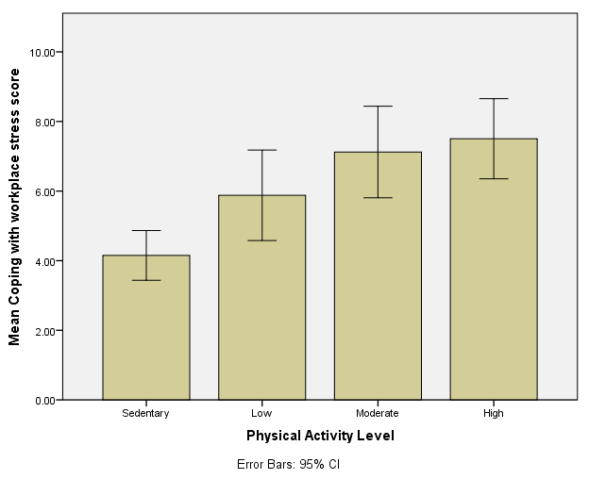
Some Formulas for Your Reference
Z score:
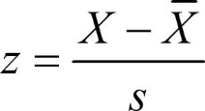 or in reverse: 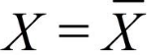$\overline{X}$+ zs
Standard Error of the Mean:
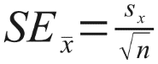
Confidence Intervals for Means of Large Samples:
$\overline{X}$ ± z*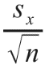
Confidence Intervals for Means of Small Samples:
$\overline{X}$ ± t*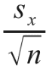
df=n-1
Maximum Margin of Error:
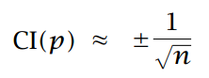
Confidence Interval for a Proportion:
