Name ______________________________________________________________

SOCY2200 Statistics Instructor: Natasha Sarkisian

Multiple Choice Test 1

Please circle your answers here, then fill them in on the bubble page. Make sure to write your name on BOTH.

1. If a distribution of an interval/ratio variable has a few scores that are much lower than the rest, the best measure of central tendency to use will be:
- Mean
- Median
- Mode
- IQR
- Variation ratio

2. The study examined how race/ethnicity, gender and social class shape academic achievement and socioemotional outcomes among eighth-graders. The unit of observation is:
- Eighth-grade student
- Social class
- Gender
- Race/ethnicity
- Academic achievement

3. For a variable indicating one's marital status, the best measure of central tendency is:
- Mean
- Median
- Mode
- IQR
- Variation ratio

4. To measure average distance of all values from their mean, we use:
- Deviation
- Standard deviation
- Range
- Interquartile range
- Kurtosis

5. A graph that best highlights univariate outliers is:
- Bar graph
- Pie chart
- Line graph
- Ogive
- Boxplot

6. Based on these results from Stata, we can conclude that age is:
- Positively skewed
- Negatively skewed
- Platykurtic
- Leptokurtic
- Approximately normal

. tabstat age, stats(skewness kurtosis)
variable | skewness kurtosis
-------------+--------------------
age | .2946918 2.204701
----------------------------------

7. The distribution on this histogram looks:
- Positively skewed
- Negatively skewed
- Platykurtic
- Leptokurtic
- Approximately normal
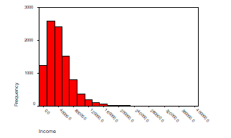

8. Based on the following frequency distribution, what is the level of measurement for this variable?
  - Nominal
  - Ordinal
  - Interval
  - Ratio
  - Unit
. tab reliten

strength of |
religious |
affiliation | Freq. Percent Cum.
----------------+-----------------------------------
strong | 1,010 36.83 36.83
not very strong | 1,041 37.96 74.80
somewhat strong | 308 11.23 86.03
no religion | 383 13.97 100.00
----------------+-----------------------------------
Total | 2,742 100.00
9. This graph is a:
- univariate bar graph
- bivariate bar graph
- multivariate bar graph
- univariate histogram
- bivariate histogram
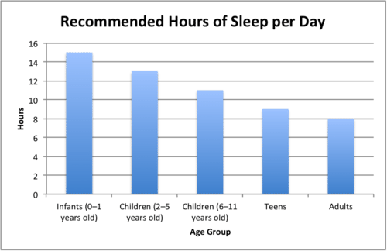

10. The key problem with this graph is that:
- the horizontal (X) axis does not start at 0
- the vertical (Y) axis does not start at 0
- a bar graph rather than a histogram was used
- the same color is used for all the bars
- the vertical (Y) axis is not labeled correctly
