SOCY2200 Statistics Instructor: Natasha Sarkisian
Handout: Confidence Intervals
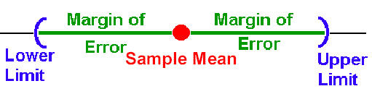
Confidence interval is an interval estimate of the population parameter (e.g., population mean) that is associated with a certain level of confidence. For example, 95% confidence interval: We are 95% sure that the true population mean is in that interval, but there is a 5% chance that we are making an error. We use alpha (α) to refer to this probability of error.
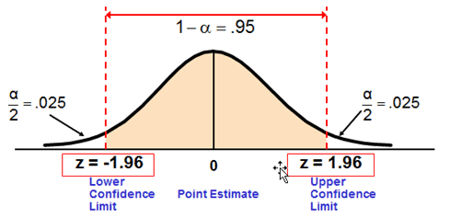
Typical confidence levels:
- 95% confidence interval: z-score=+/-1.96 (within +/- 2 SE from the mean)
- 99% confidence interval: z-score=+/-2.576
- 90% confidence interval: z-score=+/-1.645
(To be 100% sure, we would need an infinitely large confidence interval, which is not useful.)

Steps in calculation.
1. Pick the desired level of confidence (e.g., CL=90%, 95%, 99%, etc.)
2. Based on that CL, find either z or t statistic in the corresponding table:
- If sample size is large (n≥30): Divide the confidence level by 2 and enter Table B1 (Areas Beneath the Normal Curve) with that number as area value find the z score
- If sample size is small (n<30): Calculate the probability of error (alpha) by subtracting the confidence level (expressed as proportion rather than percentage) from 1, then use the two-tailed test part of Table B2 (t Values Needed for Rejection of the Null Hypothesis), enter with alpha and the degrees of freedom (df=n-1) find t value
3. Calculate the confidence interval limits using the corresponding formula:
- For large samples (n≥30): $\overline{X}$ ± z*${}_{\overline{X}}$ , where ${}_{\overline{X}}$ = $s/{√n}$
- For small samples (n<30): $\overline{X}$ ± t*${}_{\overline{X}}$, where ${}_{\overline{X}}$ = $s/{√n}$
4. Set the confidence interval (make a probability statement): Probability(X₁ ≤ μ ≤ X₂)=0.CL
5. Interpret the confidence interval in words -- this statement in words should always contain:
  - data description
  - confidence level statement
  - parameter description
  - variable description
  - population description)
  - lower and upper limits
  - units

Example A. Assume you want to have a 95% confidence interval for the mean of life satisfaction among college students. You take a random sample of n = 49, and get a sample mean of life satisfaction $\overline{X}$ = 110 and standard deviation s = 14.
1. Set level of confidence at CL = 95%
2. Obtain corresponding z. Since we want to use CL=95%, we want the middle 95% of the area under the curve, which means we want a z that excludes .025 in each tail. Half of needed 95% will be in the positive z half of the curve shown in our table, so we must divide 95 by 2. 95/2 = 47.50. Enter the table with 47.50 and read the corresponding z to be z=1.96 (the closest entry to 47.50).
3. Set the interval: $\overline{X}$ ± z*${}_{\overline{X}}$ = 110 ± 1.96 (14/√49) = 110 ± 1.96(2) = 110 ± 3.92, which means the interval extends from 106.08 to 113.92.
4. Set the confidence interval (make a probability statement):
Probability(106.08 ≤ μ ≤ 113.92) = .95

5. In words:
  - data description (based on the data from 49 students)
  - confidence level statement (we are 95% confident)
  - parameter description (population mean)
  - variable description (life satisfaction)
  - population description (U.S. college students)
  - lower and upper limits (between 106.08 and 113.92)
  - units (points on a satisfaction scale)
Statement: Based on the data from our sample of 49 students, we are 95% confident that the “true” (population) mean of life satisfaction among U.S. college students is between 106.08 and 113.92 points on a satisfaction scale.

Example B. Assume you want to get a 95% confidence interval for the mean class size at a university. You take a random sample of n = 25 classes and get a sample standard deviation of s = 10 and a sample mean of $\overline{X}$ = 70.
1. Set CL at .95.
2. Obtain t. In Table B2, we look at the column in the two-tailed part of the table that corresponds to .05, since 1-.95=.05. We read down the column marked as .05 to the row with the degrees of freedom equal to 25-1 = 24. The entry is t=2.064.
3. Calculate the confidence interval limits: $\overline{X}$ ± t*${}_{\overline{X}}$ = 70 ± 2.064 (10/√25) = 70 ± 4.128. X₁=65.872 and X₂= 74.128.
4. Set the confidence interval (make a probability statement):
Probability (65.872 ≤ μ ≤ 74.128) = .95
In words: Based on the data from our sample of 25 classes, we are 95% confident that the “true” (population) average class size at this university is between 65.872 and 74.128 students.

Confidence Intervals in Stata

We use mean command to get confidence intervals in Stata. For example:
. mean age
Mean estimation Number of obs = 1,969
--------------------------------------------------------------
| Mean Std. Err. [95% Conf. Interval]
-------------+------------------------------------------------
age | 48.1935 .3985971 47.41178 48.97522
--------------------------------------------------------------
Answer: Probability (47.41178 ≤ μ ≤ 48.97522) = .95
Based on the data from a nationally representative sample of 1969 individuals, we are 95% confident that the “true” (population) mean of age among Americans is between 47.41 and 48.98 years old.

Let’s change confidence level (95% is the default):
. mean age, level(90)
Mean estimation Number of obs = 1,969
--------------------------------------------------------------
| Mean Std. Err. [90% Conf. Interval]
-------------+------------------------------------------------
age | 48.1935 .3985971 47.53756 48.84944
--------------------------------------------------------------
Answer: Probability (47.53756 ≤ μ ≤ 48.84944) = .90
Based on the data from a nationally representative sample of 1968 individuals, we are 90% confident that the “true” (population) mean of age among Americans is between 47.54 and 48.85 years old.

